### Logging with trending

When you have mimics available, you automatically have the possibility to make a trending mimic. Trending is very useful for troubleshooting and you can also use it to log activities.

In an empty mimic make a trending instrument (see **Error! Reference source not found.**). You will get the following instrument (see Figure 2‑1). At the right side you can choose the field that you want to see in your trend-instrument.

Click with your mouse on the box at the right side of the trending window. A dialog box will appear (see Figure 2‑2). Here now you can chose the field that you want to track.

Once you have chosen a field a new box will appear. Clicking on the colored line will take you to the color adjustment window, so you can give every trend a distinct color.

Moving your mouse over the trend-lines give you an exact date and time for every event on that line (see Figure 2‑3).

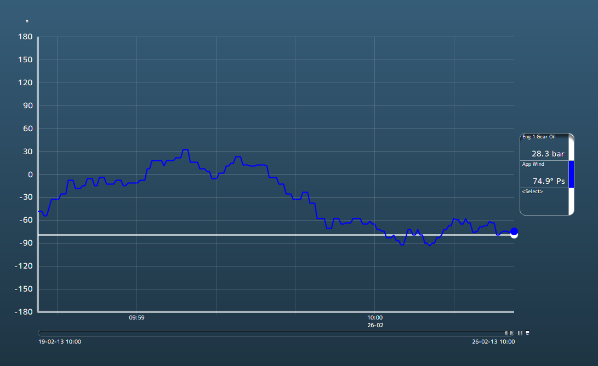

Figure 2‑1: Trending instrument

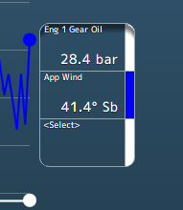

Figure 2‑2: Selection boxes

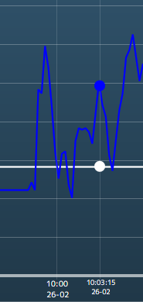

Figure 2‑3: time line

The line underneath the trending page is adjustable. You can take one of the corners to adjust the length of the trend to the interval time that you like to use (see Figure 2‑4).

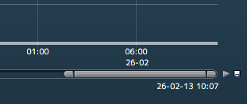

Figure 2‑4: Trending adjustments

Next to that line you can see a play button to make it interactive. You can play or pause the trending. Next to that is a save-icon. If you want to save the trending, click on the icon, find a place to save and give the file a name. NavVision will save it to a .csv file that you can open with Excel (see Figure 2‑5).

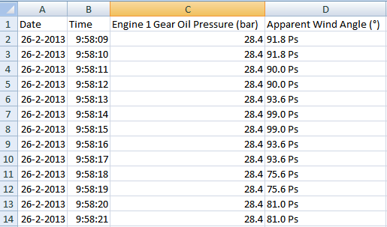

Figure 2‑5: Saved trending file

*:*

*Save the log file to D: or any other disk that NavVision ® is running on. If you save the log file on to c: (the embedded disk) you lose the log every time the system starts up again*